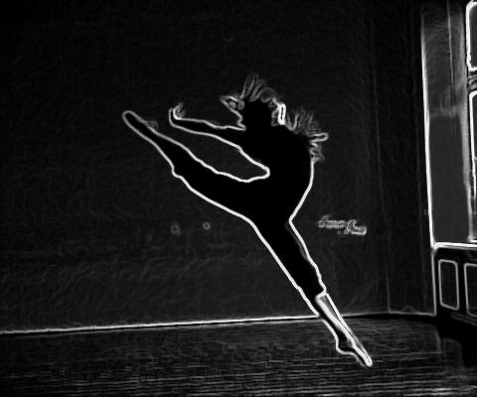
DANCE CLASS ATTIRE POLICY
- Hair is up at all times unless teacher states otherwise
- NO SOCKS-NO EXCEPTIONS
- NO JEWELRY- you can lock it up in your locker or place in your cubby
TOPS:
Athletic razor back tops, t-shirts, sleeveless tops, and leotards. Please note tops should not be low-cut and a sports bra must be worn with all tops, including leotards. No spaghetti straps/camisoles. No midriff showing. Please be careful with shirts that have arm holes that drape down that can show your sides. This is not allowed either.
BOTTOMS:
Yoga/dance pant and capris. Sweat pants can be worn when teacher specifies. Leggings are ONLY allowed if the dancer wears tights underneath and shirt covers bottom. NO holes in ANY bottoms! IMPORTANT CHANGE: The only shorts allowed in the dance room are Bermuda or knee length.
MALE STUDENTS:
Boys can wear t-shirts, gym shorts, and sweat pants in dance class.
SHOES:
Clogging is the ONLY class that requires shoes. Clogging shoes can be purchased at The Dance Exchange in Wendell. Mrs. Cyrus will send an email to the clogging class at the appropriate time with additional information.

